HISTORY of REVISION
Rev.  No. | Effective Date | Revised Page (s) | Description | Prepared by | Checked  by | Noted  by | Approved by
01 |  |  | New | DJN | HM | ON | FM
Prepared by | Checked by | Noted by | Approved by
Dexter J. Navales | Hiroyuki Mitsui | Osamu Nakai | Fumio Mizuno
Date: | Date: | Date: | Date:
IMPORTANT:
THIS COVER SHEET FORM IS PART OF THE FOLLOWING DOC SHEETS AND IS NOT TO BE DISCARDED UNLESS SUPERCEDE BY A REVISED ISSUE. UNAUTHORIZED REPRODUCTION IS STRICTLY PROHIBITED.

CONTENTS
I. General Description 3
II. Important Monitoring Items 3
1. Controllers’ Description 3
2. Instruments’ Description 3
3. Motors 3
4. Actuated Valves 3
5. Switches 3
1) 000HS901: DCS Common Acknowledge Switch 3
2) 000HS902: DCS Common Reset Switch 4
III. Interlocks/Controls 4
IV. Control Sequences 4
V. Alarms 6
VI. DCS Emergency Shutdown 6
VII. Trend Graphs Grouping 6
Annex 1: AUTO START from POWER FAILURE RECOVERY DCS Graphics 1 7
Annex 2: AUTO START from POWER FAILURE RECOVERY DCS Graphics 2 8

General Description

These graphics screens contain tabulation of critical motors that have AUTO START sequence after POWER RECOVERY. The tabulation of these critical motors includes Timer that describes the time delay for the motor to start after power has recovered. Refer to Annex 1 and 2 for the DCS Graphics Screens.

Operation Mode column is provided in the table in order for the DCS operator to identify if the equipment is in LOCAL or REMOTE mode. During normal condition, the equipment must be in remote mode thus the text indication for REMOTE is colored blue. On the other hand, the text indication for LOCAL is red in order to prompt the DCS operator of the abnormal condition and for the equipment to be set to REMOTE mode. LOCAL indication of the equipment in the DCS also appears when the equipment is de-energized in the MCC during maintenance activity on the equipment.

Status column in the table informs DCS operator the current operation status of the equipment. The text indication for RUN is colored blue while for STOP is red in order to distinguished one from the other. For the same type of equipment (e.g. 102PU08A and 102PU08B) at least one must be in operation/duty mode, therefore is the same equipment is in STOP mode, the DCS operator must immediately start one of the equipment.

These screens are provided with common acknowledge switch and common reset switch to acknowledge and reset alarms in the DCS room and in the field whenever abnormal operation condition occurs.

Link buttons (► and ◄) are present in these screens to shift from for AUTO START from POWER FAILURE RECOVERY Screen 1 to Screen 2 and vice versa. Shortcut link button to the Graphics Overview screen is also present in these screens.

Important Monitoring Items

Controllers’ Description
None

Instruments’ Description

None

Motors

None

Actuated Valves

None

Switches

000HS901: DCS Common Acknowledge Switch

The common acknowledge (ACK) button (000HS901) is used by the DCS operator to acknowledge the alarm and silence the audible alarms/horns in the DCS room and in the field. However, the alarm beacon shall remain lighted until the alarm has been reset.


Figure 2-1: 000HS901 – Common Acknowledge Switch

000HS902: DCS Common Reset Switch

The common reset (RESET) button (000HS902) is used by the DCS operator to reset all the alarms in the DCS. This switch will only function when the alarm value has been restored to normal.

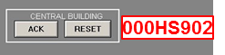
Figure 2-2: 000HS902 – Common Reset Switch

Interlocks/Controls

None

Control Sequences

Electric Power Failure occurs when the Steam Turbine Generator (STG or 711ST01) has failed and stopped producing electricity for the Plant’s consumption. When 711ST01 operation stops, 000XA001 becomes an alarm and STOP I/L (interlock) will be applied to all running equipment through initiation of ESD, SIS, and DCS ESD sequence. Auto/Man (Override) switches will be forced to Manual during power failure except Auto/Man (Override) switches for critical motors with AUTO START sequence after power recovery.

After the 711ST01 has stopped, the seven (7) Diesel Emergency Generators (DEGs or 723GE01-07) automatically run to restore power to the plant. Once electric power has been restored to the Plant, the 000XA001 alarm will return to normal and it is considered as “Power Recovery”. During this condition the STOP I/L will be released for all the equipment and the AUTO START sequence for the critical motors will be initiated.

Time Delay is set to avoid sudden and much power consumption, which may cause unexpected shutdown of the DEGs. For non-critical motors, the DCS operator can re-start the equipment after power recovery after an approval from PSU supervisor.

Table 2-1: Critical Motors with AUTO START Sequence after Power Recovery
Item No. | Equipment Tag | Time Delay (s) | Capacity (kW) | Remarks
1 | 102PU08A | 0 | 13.2 | Note 1
2 | 102PU08B | 0 | 13.2 | Note 1
3 | 102PU16A | 0 | 11.1 | Note 1
4 | 102PU16B | 0 | 11.1 | Note 1
5 | 202PU08A | 0 | 13.2 | Note 1
6 | 202PU08B | 0 | 13.2 | Note 1
7 | 202PU16A | 0 | 11.1 | Note 1
8 | 202PU16B | 0 | 11.1 | Note 1
9 | 513PU02A | 0 | 90 | Previously running 2 pumps will automatically run after Power Recovery.
10 | 513PU02B | 0 | 90
11 | 513PU02C | 0 | 90
Item No. | Equipment Tag | Time Delay (s) | Capacity (kW) | Remarks
12 | 106PU41A | 0 | 27 | Note 1
13 | 106PU41B | 0 | 27
14 | 106PU51A | 0 | 13.2 | Note 1
15 | 106PU51B | 0 | 13.2 | Note 1
16 | 106FN02A | 0 | 18 | Selected Fan will automatically run after Power Recovery.
17 | 106FN02B | 0 | 18 | Selected Fan will automatically run after Power Recovery.
18 | 106PU00A | 0 | 2.22 | Note 1
19 | 106PU00B | 0 | 2.22 | Note 1
20 | 102PU13A | 0 | 4.5 | Note 1
21 | 102PU13B | 0 | 4.5 | Note 1
22 | 102PU14A | 0 | 1.32 | Note 1
23 | 102PU14B | 0 | 1.32 | Note 1
24 | 202PU13A | 0 | 4.5 | Note 1
25 | 202PU13B | 0 | 4.5 | Note 1
26 | 202PU14A | 0 | 1.32 | Note 1
27 | 202PU14B | 0 | 1.32 | Note 1
28 | 102PU15A | 0 | 27 | Note 1
29 | 102PU15B | 0 | 27 | Note 1
30 | 102PU15A-Aux | 0 | 0.108 | Note 1
31 | 102PU15B-Aux | 0 | 0.24 | Note 1
32 | 108PU21A | 0 | 45 | Note 1
33 | 108PU21B | 0 | 45 | Note 1
34 | 108PU21A-Aux | 0 | 0.108 | Note 1
35 | 108PU21B-Aux | 0 | 0.24 | Note 1
36 | 513PU03A | 0 | 75 | Note 1
37 | 513PU03B | 0 | 75 | Note 1
38 | 106VB01A-Aux | 0 | 2.16 | Note 1
39 | 106VB01B-Aux | 0 | 2.16 | Note 1
40 | 106CP01A-Aux | 0 | 0.972 | Note 1
41 | 106CP01B-Aux | 0 | 0.972 | Note 1
42 | 109BW01A | 0 | 22 | Note 1
43 | 109BW01B | 0 | 22 | Note 1
44 | 209BW01A | 0 | 22 | Note 1
45 | 209BW01B | 0 | 22 | Note 1
46 | 109PU21A | 0 | 7.5 | Note 1
47 | 109PU21B | 0 | 7.5 | Note 1
48 | 109PU22A | 0 | 45 | Note 1
49 | 109PU22B | 0 | 45 | Note 1
50 | 109PU23A | 0 | 5.5 | Note 1
51 | 109PU23B | 0 | 5.5 | Note 1
52 | 530PU31A | 5 | 260 | Previously running 2 pumps will automatically run after Power Recovery.  Note 2
53 | 530PU31B | 5 | 260
54 | 530PU31C | 5 | 260
55 | 109BW02 | 5 | 18.5
56 | 109BW03 | 5 | 18.5
57 | 209BW02 | 10 | 18.5
58 | 209BW03 | 10 | 18.5
59 | 513PU01A | 20 | 185 | Previously running 2 pumps will automatically run after Power Recovery.  Note 2
60 | 513PU01B | 20 | 185
61 | 513PU01C | 20 | 185
62 | 109BW04A | 20 | 7.5 | Note 1
63 | 109BW04B | 20 | 7.5 | Note 1
Item No. | Equipment Tag | Time Delay (s) | Capacity (kW) | Remarks
64 | 209BW04A | 20 | 7.5 | Note 1
65 | 209BW04B | 20 | 7.5 | Note 1
66 | 106FN01A | 25 | 22.2 | Selected Fan will automatically run after Power Recovery. Note 2.
67 | 106FN01B | 25 | 22.2
68 | 530CT31 | 30 | 112.2 | Single Motor  Note 2
69 | 521CP01A |  | 96 | Compressor will run automatically after Power Recovery by detecting low pressure in compressor package even though no signal from DCS.

Note 1: Previously running pump will run automatically after power recovery.
Note 2: Motors with large power requirement shall start alone.
Note 3: Upon power fail recovery, 102/202KBS-900/850: HPAL Pump Mechanical Seal System shall initiate the following sequence:
- 102/202KBS850 shall be RESET by 102HS222 ; 102/202HV147 shall open
- 102/202KBS900 : Running pump at the time of power failure shall re-start, then back-up N2 valve 102/202HV172 shall close

Alarms

None

DCS Emergency Shutdown

None

Trend Graphs Grouping

None

Annex 1: AUTO START from POWER FAILURE RECOVERY DCS Graphics 1

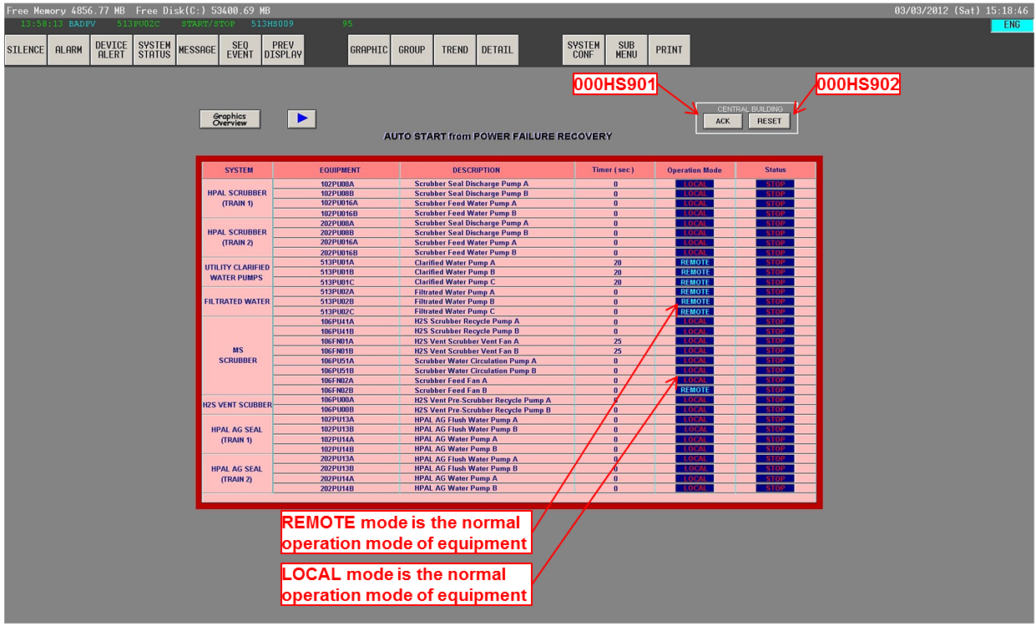

Annex 2: AUTO START from POWER FAILURE RECOVERY DCS Graphics 2

